**Topics: Descriptive Statistics and Probability**

1. Look at the data given below. Plot the data, find the outliers and find out $μ, σ, σ^{2}$

|  |  |
| --- | --- |
| **Name of company** | **Measure X** |
| Allied Signal | 24.23% |
| Bankers Trust | 25.53% |
| General Mills | 25.41% |
| ITT Industries | 24.14% |
| J.P.Morgan & Co. | 29.62% |
| Lehman Brothers | 28.25% |
| Marriott | 25.81% |
| MCI | 24.39% |
| Merrill Lynch | 40.26% |
| Microsoft | 32.95% |
| Morgan Stanley | 91.36% |
| Sun Microsystems | 25.99% |
| Travelers | 39.42% |
| US Airways | 26.71% |
| Warner-Lambert | 35.00% |

Ans- The Histogram, piechart and boxplot are plotted as follows

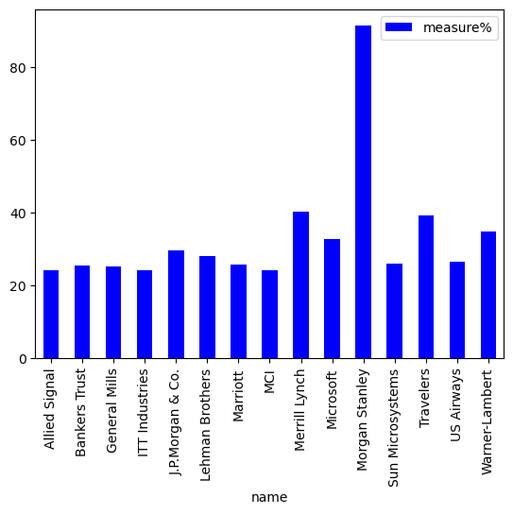

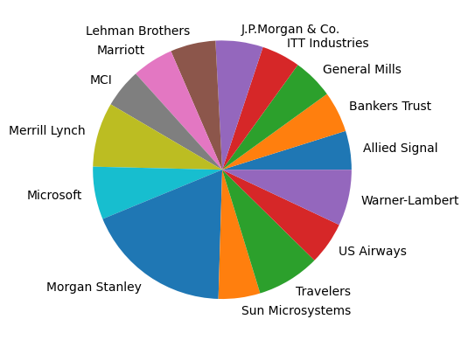

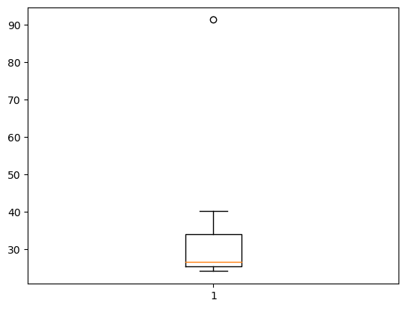

From the plots , 91.36% measure i.e Morgan Stanley is the outlier .

$μ=$ Mean = 33.27

$σ$ = S.D= 16.95

$σ^{2}$ = Variance=287.15

2.



Answer the following three questions based on the box-plot above.

1. What is inter-quartile range of this dataset? (please approximate the numbers) In one line, explain what this value implies.

Ans- .- Inter Quartile Range is

IQR =Q3-Q1 =12-5= 7

The IQR is the amount of spread in middle 50% of data.

Smaller value of IQR indicates that middle values cluster tightly.

1. What can we say about the skewness of this dataset?

Ans- The data is skewed to the right as we see the median is in left part of boxplot.

1. If it was found that the data point with the value 25 is actually 2.5, how would the new box-plot be affected?

Ans- The new boxplot will not have any outlier.

3.



Answer the following three questions based on the histogram above.

1. Where would the mode of this dataset lie?

Ans- The data is bimodal having modes at Y= 5 and Y=7.

1. Comment on the skewness of the dataset.

Ans- The data is positively skewed as more data points are clustered at initial part.

1. Suppose that the above histogram and the box-plot in question 2 are plotted for the same dataset. Explain how these graphs complement each other in providing information about any dataset.

Ans- If the boxplot is plotted the data points at end i.e. at Y=25 are considered as outliers and hence median will be 10

From the above histogram the median will be the middle most value of Y i.e. 12.5

1. AT&T was running commercials in 1990 aimed at luring back customers who had switched to one of the other long-distance phone service providers. One such commercial shows a businessman trying to reach Phoenix and mistakenly getting Fiji, where a half-naked native on a beach responds incomprehensibly in Polynesian. When asked about this advertisement, AT&T admitted that the portrayed incident did not actually take place but added that this was an enactment of something that “could happen.” Suppose that one in 200 long-distance telephone calls is misdirected. What is the probability that at least one in five attempted telephone calls reaches the wrong number? (Assume independence of attempts.)

This is problem of Binomial Distribution.

If 1 in 200 long-distance telephone calls are getting misdirected.

probability of call misdirecting = 1/200

p = 1/200

Probability of call not Misdirecting = 1-1/200 = 199/200

q = 199/200

The probability for at least one in five attempted telephone calls reaches the wrong number

n = 5

p(x) = ⁿCₓ pˣ qⁿ⁻ˣ

Required probability is

p(1) = 0.0245037

1. Returns on a certain business venture, to the nearest $1,000, are known to follow the following probability distribution

|  |  |
| --- | --- |
| x | P(x) |
| -2,000 | 0.1 |
| -1,000 | 0.1 |
| 0 | 0.2 |
| 1000 | 0.2 |
| 2000 | 0.3 |
| 3000 | 0.1 |

1. What is the most likely monetary outcome of the business venture?

Ans- $2000 is the venture likely to be successful as it has the highest probability 0.3

1. Is the venture likely to be successful? Explain.

Ans- Ans: The probability that the venture is likely to be successful is the probability that venture will make more than 0 or a profit

p(x>0)+p(x>1000)+p(x>2000)+p(x=3000) = 0.2+0.2+0.3+0.1 = 0.8

This implies that there is 80% chances for this venture to make profit.

Hence, the venture is likely to be successful.

1. What is the long-term average earning of business ventures of this kind? Explain

Ans: The long-term average = Expected value

= (-200-100+0+200+600+300) = 800

the long-term average earning= $800

1. What is the good measure of the risk involved in a venture of this kind? Compute this measure

Ans- good measure of the risk can be given as variance

Var (X) = E(X^2) –(E(X))^2

= (400000+100000+0+200000+1200000+900000)-640000

=2160000

Higher Variance implies more chance of risk.